Xango

Local Distribution Centre (LDC)
Business Narrative Ver1.1

Date | Version # | Comments
28 Nov 2006 | draft | workshop
30 Nov 2006 | 1.0 | workshop
01 Dec 2006 | 1.1

The below table is used to capture any issues that have to be addressed to enable solution design

Point | Statement | Query / Action | Response

Approval by XANGO Representatives

XANGO Business Manager:
____________________

Signature / Date

____________________
Name

Approval by BAX Representatives

BAX Business Manager:
____________________

Signature / Date

____________________
Name

Table of Contents

Approval by XANGO Representatives 2
Approval by BAX Representatives 2
1. Business Narrative 4
2. Goals 4
3. General Information 5
4. Terminology 7
5. Abbreviations 7
6. Inbound 7
7. Outbound 8
8. Inventory Management 10
9. Labels & Reports 10
10. Assumptions 11
11. Appendix 12

Business Narrative

The Business Narrative serves as an important business blueprint in BAX Implementation Documentation. This diagram shows the relationship of the BN to the other steps of Implementation methodology.
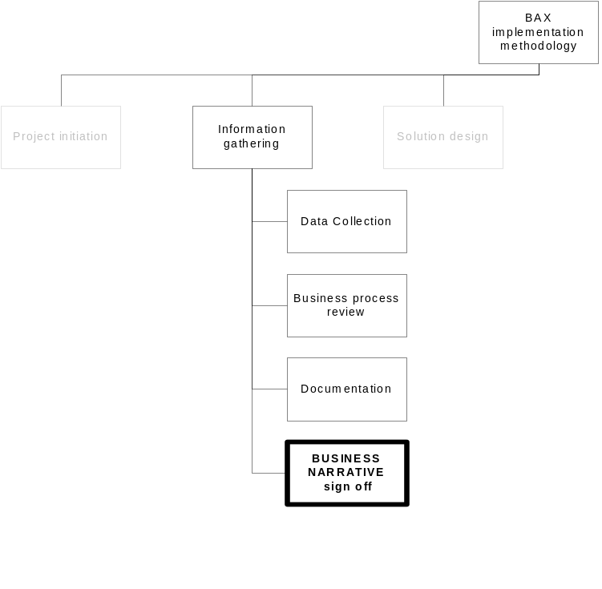

Goals

The goals of the Business Narrative are to:

- Summarize BAX Global requirements in the warehousing and distribution procedures to meet the business requirements, software and systems of the XANGO Local Distribution Centre.

- Provide a blueprint for any custom code or modifications to the Exceed WMS System.

- Give BAX Global and XANGO business owners a good map of how the processes (including system) will be developed to meet the business requirements.

- The basis of this document will be used to develop training materials.

General Information

  - Business Overview

The products originate from XANGO US and flow into the XANGO Local Distribution Center in Singapore, managed by BAX Global.

XANGO customers have the following ordering options
- Will call
- Web ordering
- Auto-Ship

XANGO customers have the following pick-up options
- Personal pick-up at Sales Office
- Delivered to home

The diagram below summarizes the business scope, product and ordering flow

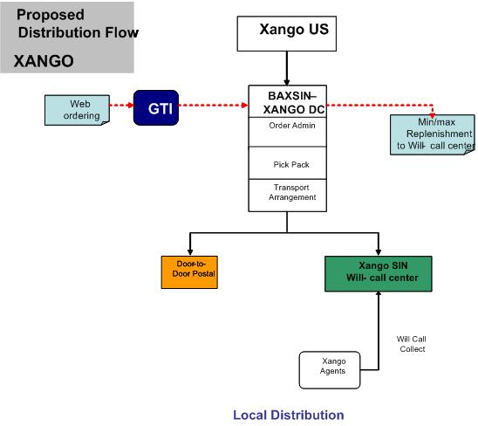

  - Product Overview
    - XANGO will launch product in Singapore in December 2006
- Xangosteen [1 SKU for juice in box and 1 for individual bottle]
- Marketing materials [7 SKU – 2 DVD, 1 CD, 1 dist kit, 3 brochure] can be ordered individually
    - Each box contains 4 bottles or single bottle SKU [single for replacement or new order]
    - A box of 4 bottles retails and inventorized as 1 unit
    - The Products will be sold in 2 different pack sizes
- {pack size 1}
- {pack size 4}
    - Product restrictions
- Do not freeze
- No aircon control required
- Shelf life 2 years from manufacturing date [best by date]

Note: average 3months inventory

    - Operating hours (Singapore Sales Office)
- Customer Service Counter
  - 10am-8pm Mon-Fri
  - 10am-2pm Sat
- Admin Office
  - As above

  - BAX Implementation

    - Logistics Services

BAX will support its range of logistics services with the BAX Warehouse Management System (WMS)

The BAX WMS is a warehousing and distribution management system designed to manage the tracking of goods as they move in, around and out of the XANGO Local Distribution Center. The Exceed WMS is an auditable application, maintaining all records of receipts, moves, adjustments and withdrawals.

The functions BAX will perform for XANGO includes:

- Inbound
- Receiving of goods
- Storage

- Inventory Management
- Lot / Expiry date controls
- SKU Maintenance
- Periodic Stock counts [at month end]
- Reports

- Order Fulfillment
- Order upload
- Order picking
- Order packing
- Value-Add - re-labeling, Kitting
- Allocation Rules
- Shipment labeling
- Outgoing document preparation (Delivery Order, Packing List for Sales office; Consignment notes)
- Delivery Planning and coordination

To facilitate the above functionality BAX recommends automated messaging. This can be developed to allow information to be exchanged freely between XANGO systems and BAX systems. These interface messages could be but not limited to:

940 - Shipment Order message (XANGO to BAX)
945 - Shipment Order Confirmation message (BAX to XANGO)

Terminology

Nil

Abbreviations

Nil

Inbound

6.1 ASN Management
6.1.1 BAX receive Advance Shipment Notification (ASN) from XANGO logistic via
- Email (shipping documents in pdf format)

6.2 Initial Receipt (Physical Receipt, contents unchecked)
6.2.1 Upon goods arrival, BAX performs the following checks
- visual inspect for external damages,
- package count against delivery documents
6.2.2 Record discrepancies / external damages & email to Xango contacts immediately.
6.2.3 Sign over receipts
6.2.4 Place goods in detail check area

6.3 Detail Check (Content check)
6.3.1 Create ASN from WMS
6.3.2 Print ITS (Inbound Tally Sheet)
6.3.3 Perform detail checking
- SKU
- Expiry date
- Batch / Lot number
- Country of origin (default to US)
- Damaged
(visual checks only; no quality checks will be done)
- Record quantity received
(For original cartons, only carton quantity on external label will be counted)

    - Apply Pallet LP
- Where 1 pallet contains more than 1 SKU, clearly separate the 2 SKU and apply 1 LP for each SKU

6.4 System updating
6.4.1 Perform receipt into WMS
6.4.2 Confirm receipt report to XANGO contact via
- Email
    - Putaway to location
- Update location number

  - Exceptions Handling
    - Wrong part number
- Document SKU A but physical SKU B
(take in according to physical item received)

    - Shortage
- Document Qty 1000 but physical qty 999
(take in according to physical qty received)

    - Excess
- Document Qty 1000 but physical qty 1001
(take in according to physical qty received)

    - Damaged
- Dented retail Unit box
- Retail unit box broken and not able to hold contents
- Leakage due to broken bottles
(take picture of damaged items and email to XANGO contact; move damaged item to Damaged location)

    - Expired
- BAX will arrange disposal after approval from Xango contact (there are no specific disposal procedures from Xango, BAX may arrange with disposal agents)

Outbound

7.1 Order Fulfillment
7.1.1 BAX receives Shipment Order Information from XANGO via
- Message 940 (Pull from GTI once a day at 9am)
- Emails or Fax (from will-call office)

Note: there will be 2 types of orders
- Orders to customers
- Orders to Sales Offices

7.1.2 Consolidates order based on Order Consolidation criteria
- No consolidation

7.1.3 Allocation
- FIFO
- If Shelf life <=6months, block allocation
- Ship partial not allowed (if insufficient qty, inform Xango contacts)

7.1.4 Print Pick List
7.1.5 Performs Picking by LP
7.1.6 Print Order List
7.1.7 Pack to Order
    - Print and Apply Shipping Label (tracking number can be WMS)
7.1.9 Prepare and Print ship documents
7.1.9.1 Local delivery to Sales office (BAX Delivery Order, Packing List)
7.1.9.2 Local delivery to customers home
    - Postal consignment note

7.1.10 Upon goods dispatch from LDC, performs system closure
- Ship wave in WMS
  - For direct ship, enter consignment note
- Shipment confirmation to XANGO via
  - Message 945
  - Tracking number must be sent in the message 945

** the shipment tracking number can be a WMS number but it must be displayed on the physical goods, physical document as well as system records

7.2 Returns
7.2.1 Place returned products at quarantine locations.
7.2.2 Update return information into GTI.
7.2.3 Visually inspect products for external damages
7.2.4 Check if
- Product does not have lot number
- Product shelf life is less than or equal to 6 months from expiry date
- Product is scuffed, scratched, scarred, broken, cracked, or leaked. Disposed unaffected bottles from the same case together.
- Bottle’s seal is broken

    - Check if cartons or packing materials are damaged, crushed, torn or stained.

    - If product and/or carton and/or packing material is damaged, BAX take pictures and inform XANGO contact.

    - Upon confirmation from XANGO, BAX dispose products that have defects in 7.2.4 or destroy cartons and packing materials with defects in 7.2.5.

    - BAX keep a manual tracking record of disposal.

    - If cartons or packing material is damaged in 7.2.5, remove the product and replace into new XANGO cartons and packing material.

    - For returned good products and repacked products in 7.2.9, WMS to issue and keep new 8 digit lot number in separate field for good product (do not print the new lot number on the product itself)
- Three (3) Letter Location code
- Two (2) digit year reference
- Three (3) digit Julian dates

7.2.11 Received into WMS. Move the good and repacked product to physical good location.
7.2.12 BAX to inform XANGO contact the returned good products and repacked products by email.

7.3 Order Revisions and Cancellations
    - Cancellations
- XANGO to inform BAX by email

Inventory Management

  - Shelf-life management
- Shelf life of products is 2 years
- good for ship is defined as greater or equal to 6 months remaining
- block shipment if shelf life remaining is less than or equal to 6 months

  - Periodic Stock Counts
- BAX performs periodic stock counts on every month end

  - SKU Maintenance
    - SKU master setup
- SKU
- Description

Labels & Reports

  - Operational Reports

Name | Frequency | Time | Type | Comments
ITS | Transactional | At time of receiving | Report
Pick List | Transactional | At time of Order Allocation | Report
Packing List | Transactional | Prior to material ship out for Sales office | Report
Billing Reports | Monthly | After month end | Report
All shipping documents will be on the BAX letter head.

  - Customer Reports

Name | Frequency | Time | Type | Comments
receiving | Per occurrence | End of day
Outbound shipment | weekly | Monday
Inventory Balance Report | Bi-weekly | End of day
Monthly CC | Last calendar day of month | End of day
Return Report | Per occurrence | Immediately after return for rework

  - Labels

Shipping Label format (as attached in Appendix)

Assumptions

Point | Statement | Assumptions | Confirmations
1 | Monthly Inbound Volume | 1-1.5 shipments per month
2 | Monthly Outbound Volume | 2500 orders per month (14-28% monthly growth)

Appendix

  - Sample of BAX Shipping Mark

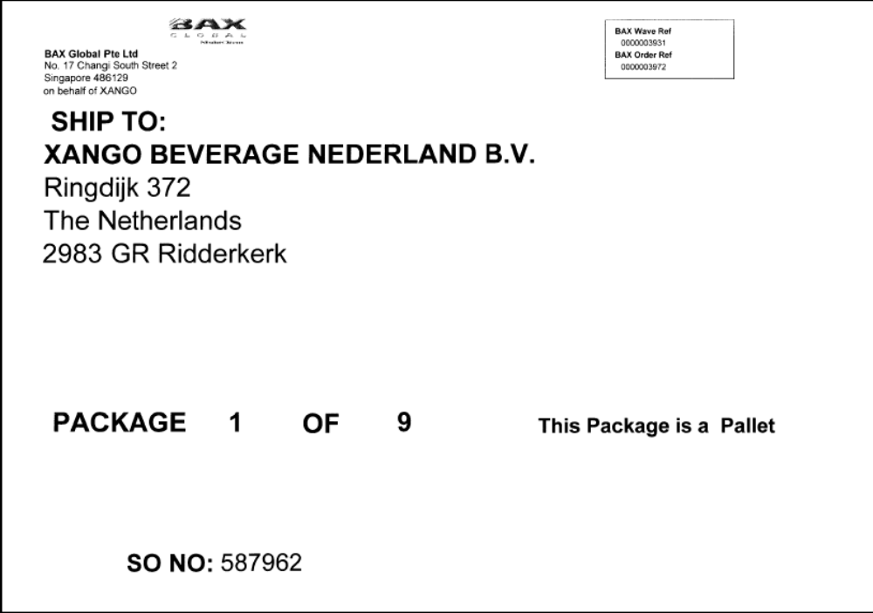

  - Sample of SingPost Shipping Label

